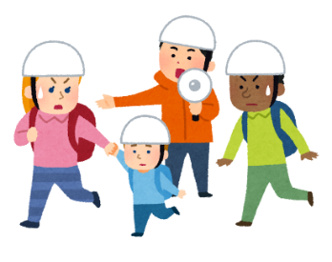 **Seto City Comprehensive Disaster Prevention Drill 2025(7th year of Reiwa era)**

**(英語版)**

**~Seto City Citizen-Wide Disaster Prevention Drill~**

Let’s join

"Home Disaster Prevention Drill!”

Date and Time: Sunday, November 16th, 8:00 AM

Place: At each of your house

Disaster prevention drills are practices to prepare for disasters such as earthquakes in advance. They are also being held in areas where you are living in. We never know when an earthquake will strike. So, let’s participate

in disaster prevention drills to cope with it.

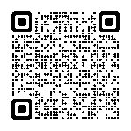

**What we should prepare for before an earthquake occurs ➡**

**≪How to proceed with the disaster prevention drill on November 16th≫**

**Home Disaster Prevention Drill**

**（**All of residents, let’s join this drill at home (each household) starting at 8:00 AM**.）**

**Details are on the reverse side of this paper.**

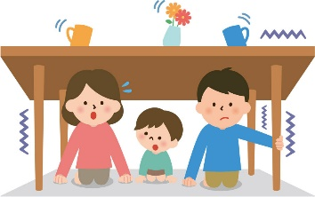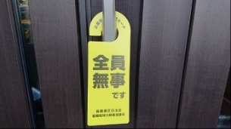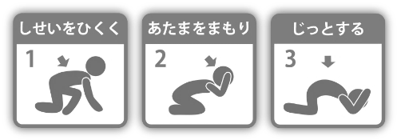

**Regional Disaster Prevention Drills in each Ren-ku (District)**

**The disaster prevention drills will be held in each Ren-ku as follows**

**①　Safety Confirmation Drills** (This is the drill for neighbors

getting together and checking on each other's safety)

**②　Other drills will be conducted by each Ren-ku**

（such as evacuation shelter opening/ operation, and so on）

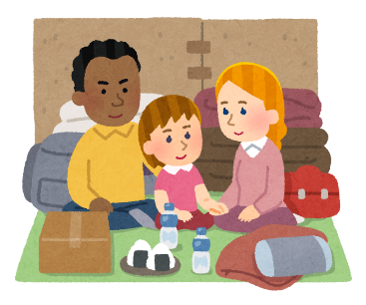

**Contact about this drill: Seto City Hall,Disaster Prevention and Safety Division　TEL：0561-88-2600**

**【About time schedule of Home Disaster Prevention Drill】**

**① Shakeout Drilｌ　（From 8:00 AM for one minute!）**

８：００

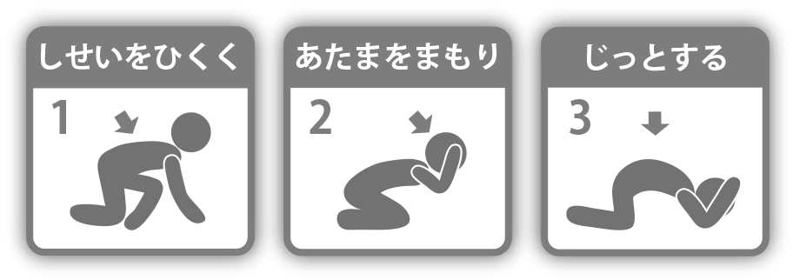These are actions to protect your life from earthquake shaking.

**１ Stay low**

**２ Protect your head**

**３ Stay still**

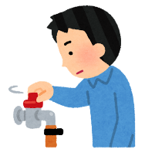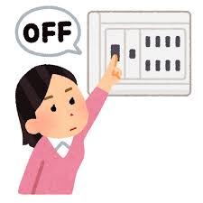**② Preventing Secondary Disasters**

Once the earthquake shaking has subsided, turn off the main

gas valve and the breaker at electricity distribution board

to avoid secondary 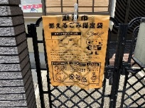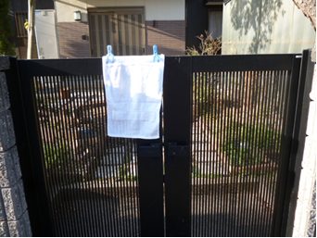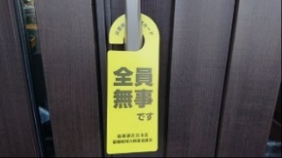disasters.(In the drill at this time, only

pointing at and checking on them are enough to do.)

**③ Posting Safety Indication Tag**

８：１０

**Purpose:** To inform neighbors that you are safe in the disaster.

**Usage:** Post it in a visible location such as the entrance of your house.

For this, please use "safety indication tags" created by each Ren-ku, towels, or city-designated combustible garbage bags.

(About time schedule of Home Disaster Prevention Drill is an estimate only.)

**[To the members of community association or neighborhood association]**

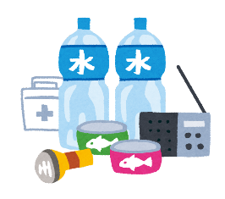Please note that house without safety indication tag in this drill may be contacted (e.g., by ringing the doorbell) by officials.

**④ Prepare and check the contents of your**

**emergency go bag　and emergency supplies**

Prepare your “emergency go bag” containing essential items for evacuation, and emergency supplies to continue evacuation life at home, and review them during this drill!

**⑤ Check and consider the hazard mas and evacuation shelter**

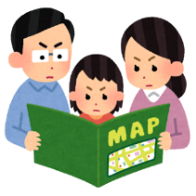Using the hazard map, check the disaster risk level of your house and surrounding area. And also, be sure to identify the location of “designated evacuation shelters” to go in a disaster, as well as

“the group temporary assembly areas” where

local residents can meet and confirm each safety.

The content of regional disaster prevention drills varies by region (Ren-ku).

For details, contact your community association.

**When check earthquake hazard map, click here.→**