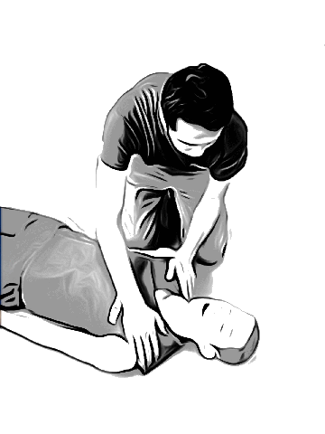
Cardio-pulmonary resuscitation
- Check the reaction.  Make sure whether there is a reaction by tapping on the shoulder or not. |  | Are you all right?
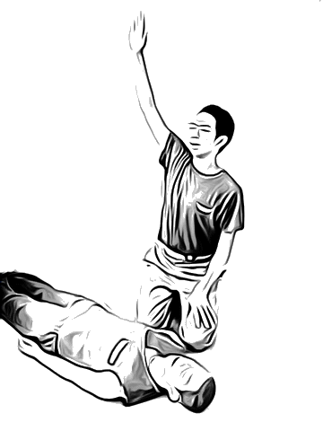  ② Call for help.  Gather people in a loud voice. Call 119 and call an ambulance. | 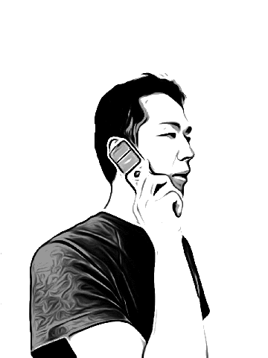  Please come! Call an ambulance and bring AED!  Please come with a person who speaks Japanese. | I need an ambulance.  A person fell down  (say an address)  I can’t see any reaction on him/her.
- Confirmation of the
Breathing.
- Chest compression.  If he/she doesn’t breathe, start chest compression promptly.  Strongly press the middle of the chest early. | 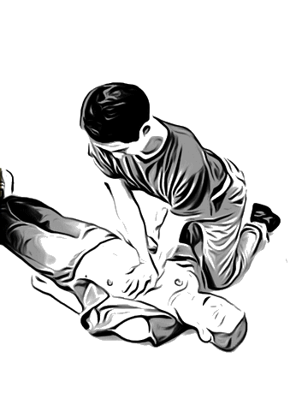 | 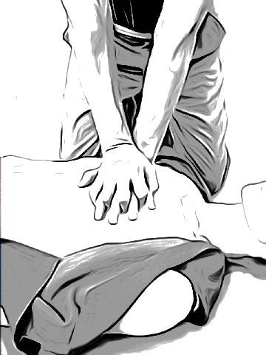
- Continue chest compression until emergency services come.
    - When you get AED, switch it on. Then, put a pad on him/her. Push the shock button on the AED keeping the patient off after the button gets flashing. Please continue chest compression afterwards.

